Payeer for CMS Joomla 3.7.1 - DJ-Classifieds 3.2.2

In admin panel go to “Extensions -> Manage -> Install”.
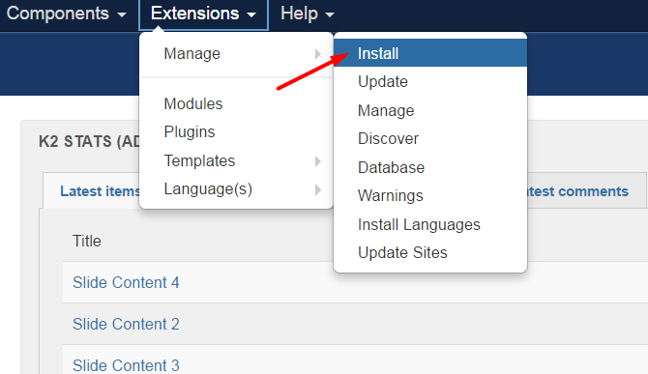

On the tab “Upload Package File” upload djcfPayeer.zip.
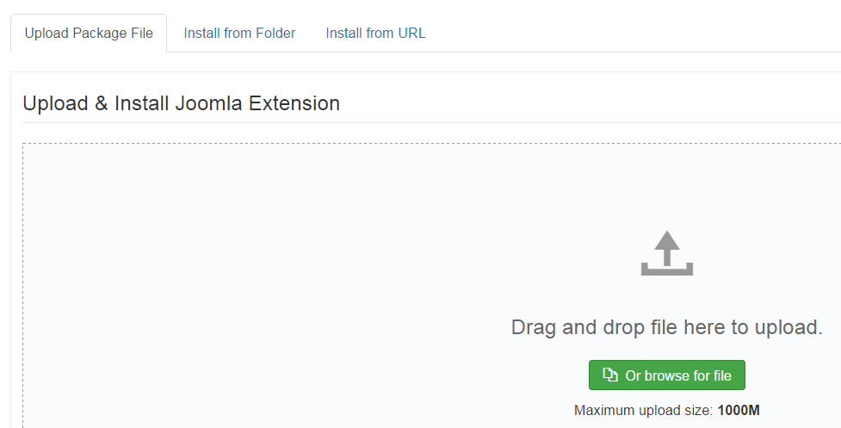

After downloading, you should receive a notification about the successful installation of the plugin.
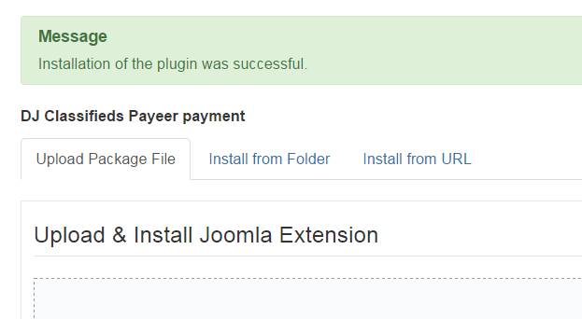
Open the plugin page DJ-Classifieds by going to “Components -> DJ-Classifieds”.
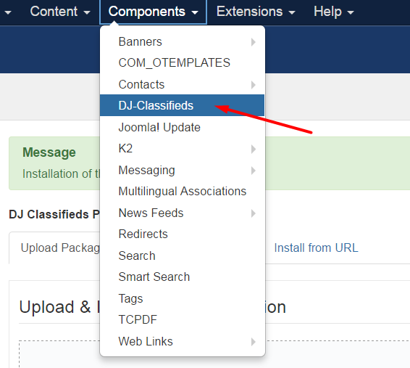

Go to “Payment plugins".
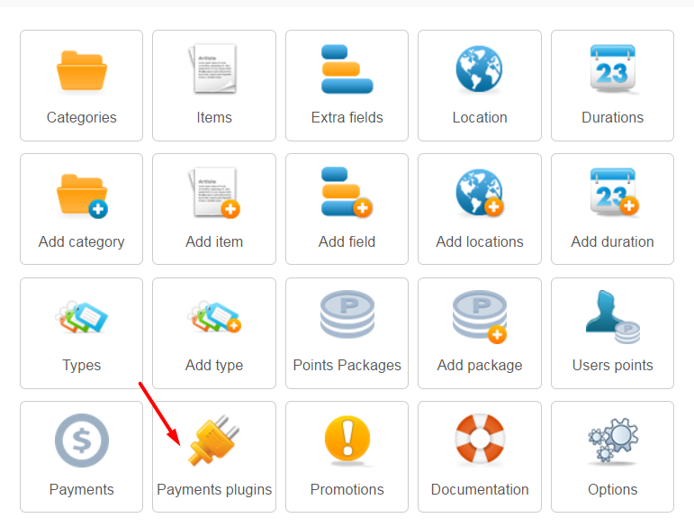

In the list of plugins, open DJ Classifieds Payeer payment.
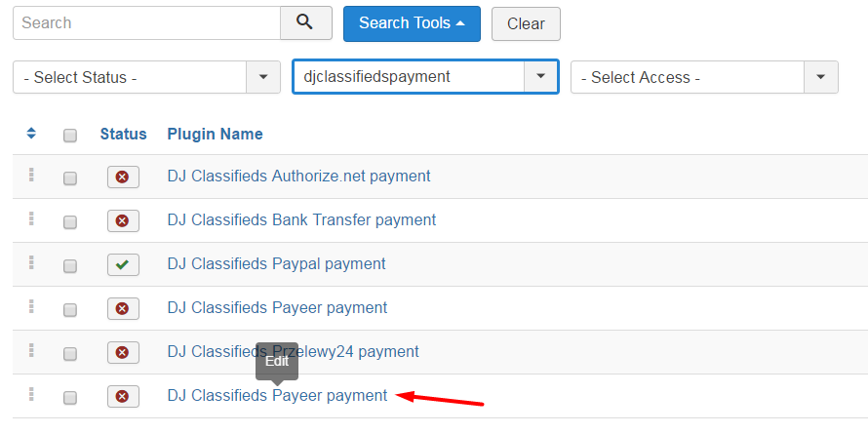
In the settings specify the settings of the payment system Payeer.
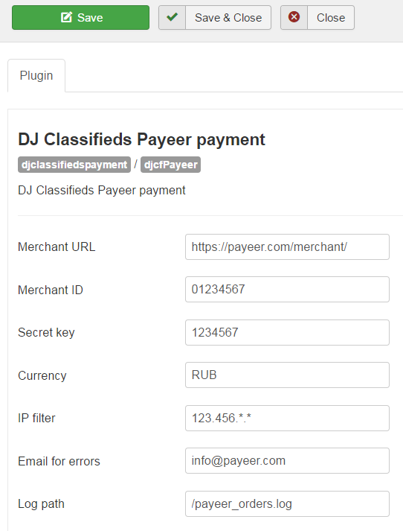

Merchant URL: the default path to the payment https://payeer.com/merchant/
Merchant ID: id of your store in the system Payeer.com (can be found in the personal cabinet).
Secret key: the secret key of your store, also issued to you when registering in the system.
The path to the log file: if you specify the path to the file logging, you will be recording information about payments via Payeer.
IP filter: You can specify the list of all trusted ip addresses of servers, separated by commas. You can also specify a mask instead of the ip address. If the field is empty, checking for trusted ip addresses is not performed.
For example:
192.168.71.87, 192.165.83.17, 192.178.34.15
Or 192.*.71.87, 192.165.83.*, 192.*.34.15
Or *.*.*.* - all available ip addresses

Email for warning send: enter your email address to receive notices in the event of an error of payment. The letter will state the reason and basic information about the payment.
Specify the status “Enabled” and click “Save & Close”.
Then on the website payeer.com in the dashboard, enter the URL in the store settings.

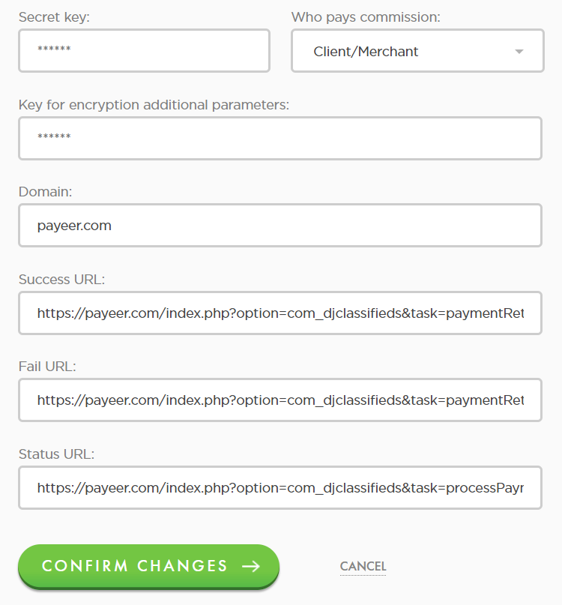

Success URL
http://*****/index.php?option=com_djclassifieds&task=paymentReturn&r=ok
Fail URL
http://*****/index.php?option=com_djclassifieds&task=paymentReturn&r=error
Status URL
http://*****/index.php?option=com_djclassifieds&task=processPayment&ptype=djcfPayeer&pactiontype=notify
Where ***** is your domain.
Confirm changes.
Module Payeer for CMS Joomla 3.x.x – DJ-Classifieds 3.2.2 configured.

